<https://www.researchgate.net/publication/255513126_Computer_Game_Audio_The_Unappreciated_Scholar_of_the_Half-Life_Generation> - read through the report

use of audio in games, its effect is under-exploited.

Spent one week thoroughly attempting to build the tinker-cad similar project but with constraints of each part taken in. This proved to not be possible and I had over-estimated it. However, there is no braille audio games, and there is no way of teaching braille.

I am going to create a braille audio game, its main objective is to;

* Increase awareness of braille, most people haven’t even heard of it
* Encourage future braille interpreters, highlight the problems
* Lack of any games, especially modern that teach braille
* A new and novel way of teaching braille code systems
* Possible highlight audio games as entertaining and engaging learning platform

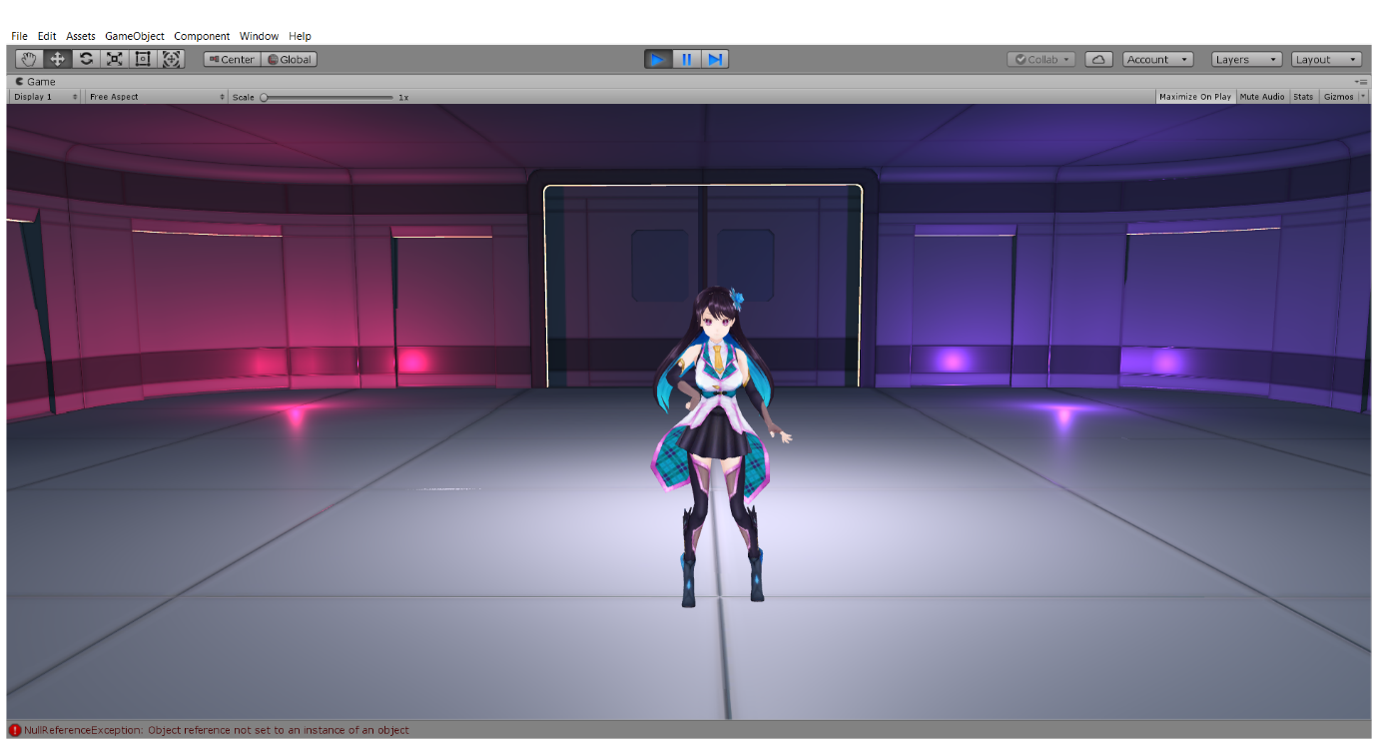

**A**

**010**

**E**

Frequency of the letter is the only thing that needs to change between songs, adapts to different types of songs, that is what separates audio games from other types of games.

I’ve attached an a publisher document describing the concept of the game.

Assets I may use:

<https://assetstore.unity.com/packages/3d/characters/amane-kisora-chan-free-ver-70581>

<https://assetstore.unity.com/packages/3d/characters/unity-chan-model-18705>

<https://assetstore.unity.com/packages/3d/environments/3d-free-modular-kit-85732>